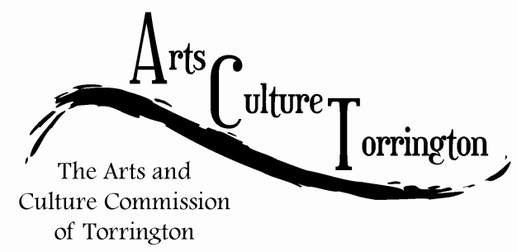

MEETING AGENDA

January 25, 2017 **|** 8:00am **|** City Hall Auditorium

1. Call To Order
2. Public Comment
3. Approve minutes from special meeting 01/18/2017
4. Budget Review
5. **Event Update:** “Saturday in the Park”

1. **Discussion:** Creating of new “Community Engagement” sub-committee combining our website, social media, marketing and any new short term public outreach and/or public engagement initiatives
2. **Project Update:** Photos in City Hall public areas
3. **Discussion:** Creation of a sub-committee for our new “City Space” initiative
4. New Business
5. Adjournment